Project Design Phase-II

**Technology Stack (Architecture & Stack)**

|  |  |
| --- | --- |
| Date | 03 October 2022 |
| Team ID | PNT2022TMID31255 |
| Project Name | Estimate The Crop Yield Using Data Analytics |
| Maximum Marks | 4 Marks |

Technology Stack (Architecture & Stack)

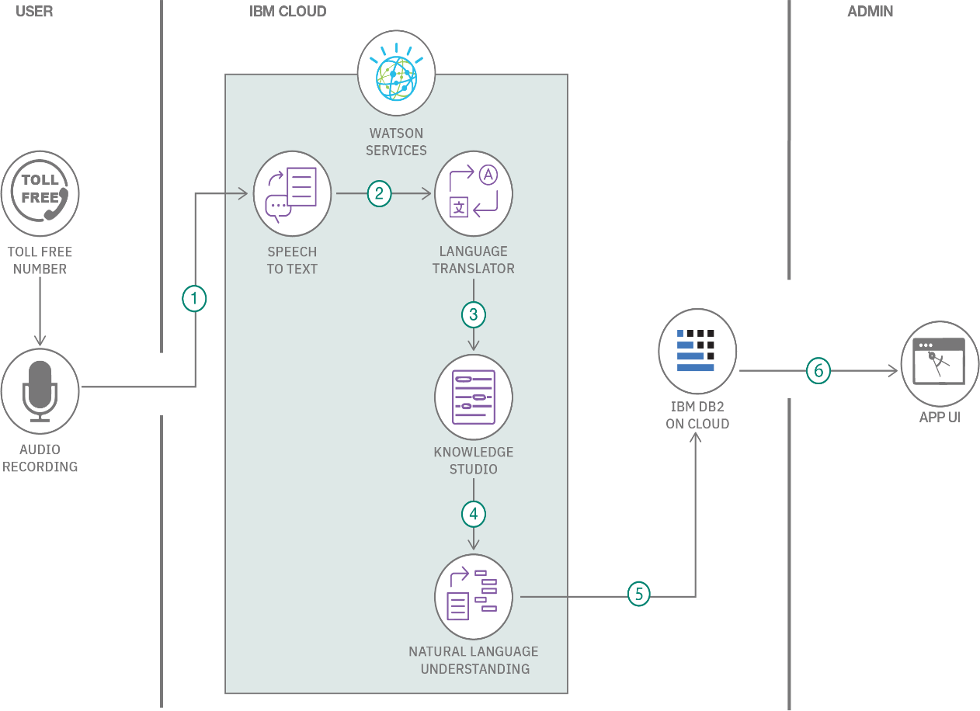

Table - 1: Components & Technologies:

|  |  |  |
| --- | --- | --- |
| **S. No** | **Components** | **Technology** |
| 1. | User Interface | HTML |
| 2. | Application Logic-1 | Python |
| 3. | Application Logic-2 | IBM Watson STT service |
| 4. | Application Logic-3 | IBM Watson Assistant |
| 5. | Database | MySQL, NoSQL, etc. |
| 6. | Cloud Database | IBM Cloudant |
| 7. | File Storage | IBM Block Storage or Other Storage  Service or Local Filesystem |
| 8. | External API-1 | IBM Weather API, etc. |
| 9. | External API-2 | Aadhar API, etc. |
| 10. | Machine Learning Model | Object Recognition Model, etc. |
| 11. | Infrastructure (Server / Cloud) | Local, Cloud Foundry, Kubernetes, etc. |

Table-2: Application Characteristics:

|  |  |  |
| --- | --- | --- |
| **S. No** | **Characteristics** | **Technology** |
| 1. | Open-Source Frameworks | Technology of Opensource framework |
| 2. | Security Implementations | SHA-256, Encryptions, IAM Controls, OWASP |
| 3. | Scalable Architecture | Technology used |
| 4. | Availability | Technology used |
| 5. | Performance | Technology used |